Task1. Created a s3 bucket with no public access and uploaded files and enabled server access logs and added a target bucket for logs to store
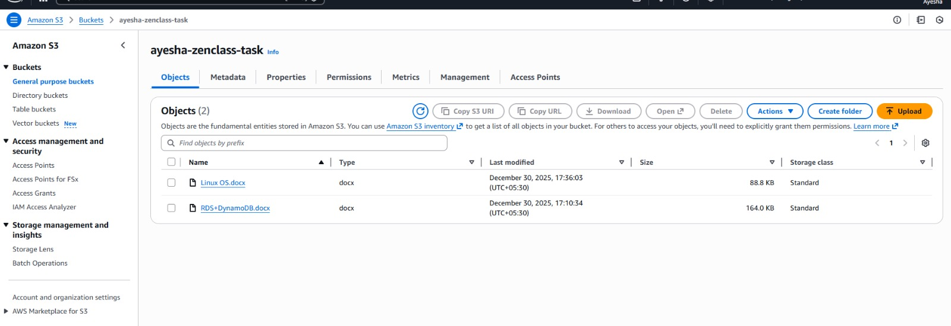
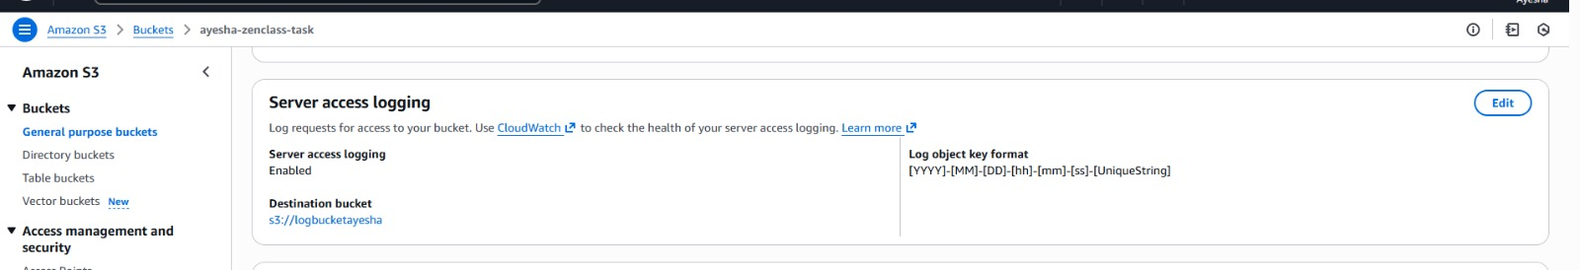
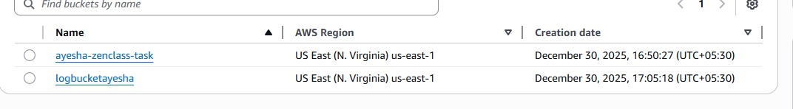
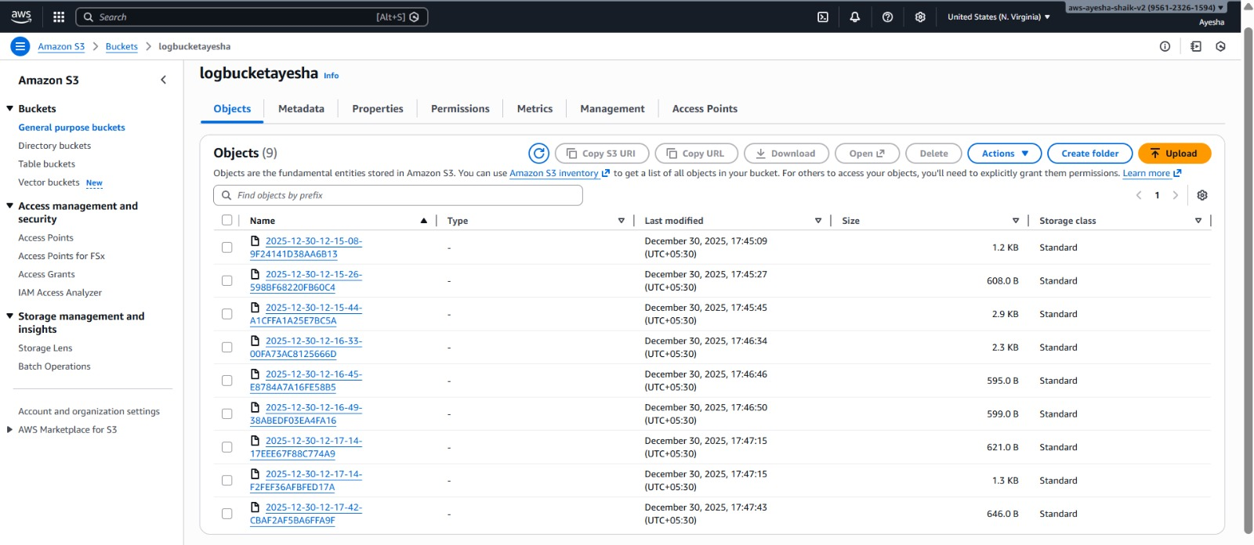
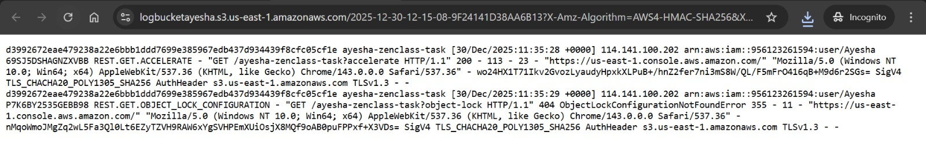

Task 2.Launched Two ec2 instances 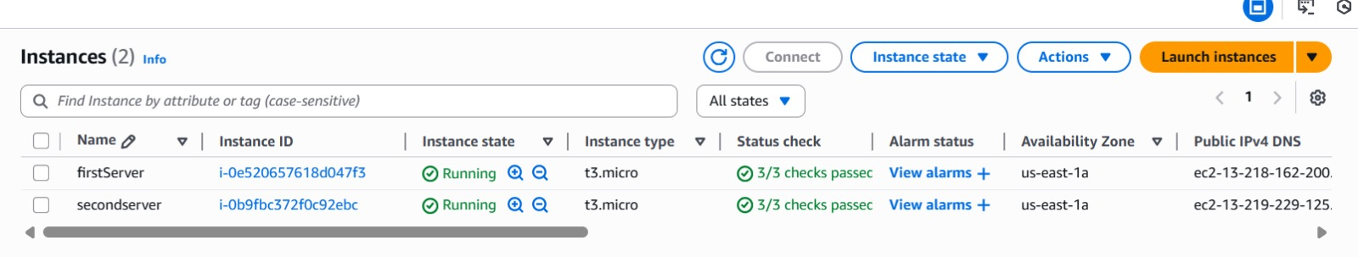

Connected to ALB
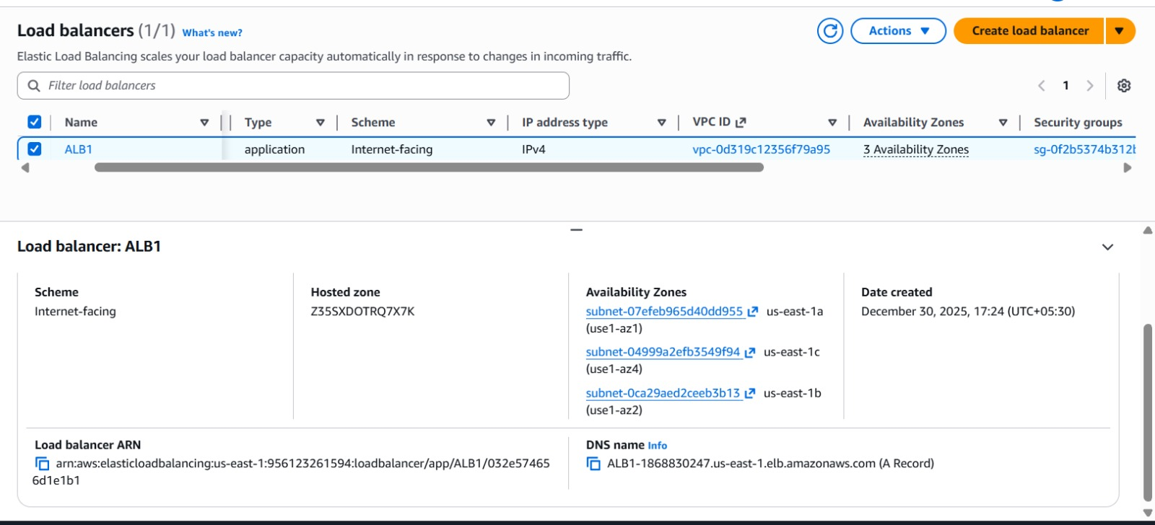
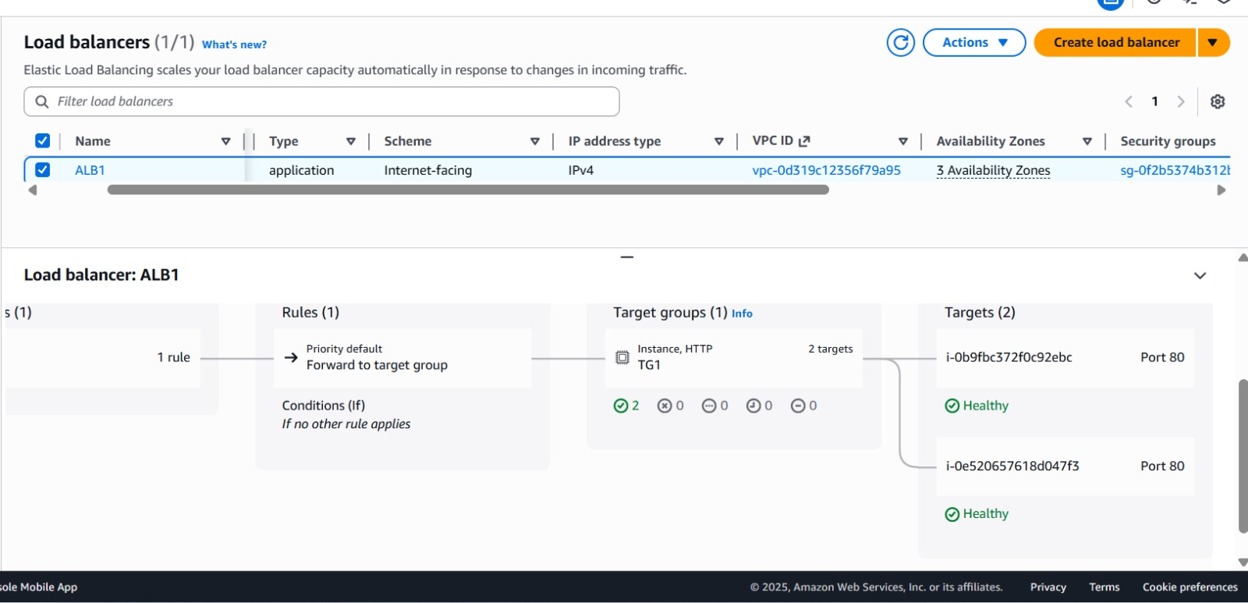

Output traffic from load balancer
